ITM University Gwalior
School of Computing and Intelligent Systems
Project-Based Learning (PBL)
Mini Project Report — Submission Format

Course: Data Analytics Using Python
Course Code: CSL0312
Program: B.Tech. CSE (Artificial Intelligence & Machine Learning)
Semester: III Section: F
Academic Session: July–Dec 2026
Project Details
Project Title: Impact of Rainfall and Soil Parameters on Crop Production
Domain (as per Section 6): Agriculture Analytics
Team Leader Name & Roll No.: K . Vishnu Vardhan (BETN1AI25175)
Team Member Name & Roll No.: S. Shiva Prasad(BETN1AI25210)
Team Member Name & Roll No.: S. Bhanu (BETN1AI25209)
Faculty Mentor: H . N.Verma
Date of Submission: 15 – 10 - 2026

1. Introduction & Problem Statement
Describe the background, the real-world problem being addressed, its significance, and the scope of the project (200–300 words).
Introduction
Agriculture is an important sector that depends on environmental conditions, soil quality, water availability, and proper irrigation practices. Rainfall plays a significant role in crop growth because it provides the water required for plant development. However, insufficient rainfall can lead to water stress and reduced crop production, while excessive rainfall and irrigation may cause waterlogging, nutrient loss, and soil degradation. Therefore, understanding the relationship between rainfall, soil conditions, and crop production is important for improving agricultural practices.
Problem Statement
Farmers need suitable information about rainfall, soil characteristics, and irrigation requirements to manage water resources effectively. When water availability and soil conditions are not properly considered, crops may not receive the required amount of water. This can affect crop growth, productivity, and the efficient use of agricultural resources.
The project, “Impact of Rainfall and Soil Parameters on Crop Production,” aims to analyze agricultural data using Python-based data analytics techniques. It focuses on examining rainfall, soil type, irrigation, temperature, humidity, crop type, season, location, and other relevant attributes available in the dataset. Exploratory Data Analysis (EDA), statistical summaries, and visualizations will be used to study patterns and relationships between these factors and crop production.
The scope of this project includes data collection, data cleaning, preprocessing, exploratory analysis, statistical interpretation, and visualization. The analysis is intended to identify agricultural conditions associated with variations in crop production. The findings may help improve understanding of agricultural data and support informed decisions regarding irrigation and crop management. The project will also provide a foundation for future development of data-driven agricultural decision-support systems.
2. Dataset Description & Source
Dataset Name: Agricultural Dataset
Source / Organization: Kaggle
Dataset Link (URL): https://www.kaggle.com/datasets/imtkaggleteam/agriculture-dataset-karnataka
Type of Dataset: ☐ Public ☐ Private ☐ Self-Collected
Number of Records: 3,158
Number of Attributes/Columns: 12
Confirm the dataset meets the minimum quality criteria specified in Section 7 of the PBL guidelines: at least 500 records, at least 5 attributes/columns, and minimal missing values (or a documented justification if extensive cleaning was required).
☐ Dataset meets minimum quality criteria (Section 7)

Brief description of attributes/columns:
The agricultural dataset contains information related to agricultural production and the environmental conditions associated with crop cultivation. According to the approved synopsis, the attributes include rainfall, temperature, humidity, crop type, season, area, irrigation, soil type, crop yield, and price, along with other available fields.
These attributes will be examined to understand variations in crop production under different agricultural conditions. Rainfall, temperature, humidity, and soil-related attributes will be considered environmental factors, while crop type, season, location, irrigation, area, and yield will be analyzed according to their availability and relevance in the dataset. The exact column names and data types will be confirmed during dataset inspection.

3. Data Cleaning & Preprocessing
Document the steps taken to clean and prepare the dataset — handling missing values, duplicates, outliers, data type conversions, encoding, normalization/scaling, etc. Include relevant code snippets or summaries.
Data cleaning and preprocessing are important steps in preparing the agricultural dataset for reliable analysis. Python libraries such as Pandas and NumPy will be used to inspect, clean, and organize the data.
- Dataset inspection: Load the dataset and examine its dimensions, column names, data types, and sample records using Pandas.
- Missing-value analysis: Identify missing values in each column and decide how to handle them according to the type and importance of the data.
- Duplicate removal: Check for duplicate records and remove them where appropriate.
- Data type correction: Verify that numerical attributes are stored in suitable numerical formats and categorical attributes are represented consistently.
- Inconsistent-value checking: Examine entries for inconsistent category names, invalid values, and formatting issues.
- Outlier inspection: Use summary statistics and suitable visualizations, such as box plots, to identify unusual observations and investigate them before deciding whether any action is necessary.
- Data preparation: Select relevant columns and prepare the cleaned dataset for exploratory analysis and visualization.
import pandas as pd
import numpy as np
# Load the dataset
df = pd.read_csv("/content/archive.zip")
# Basic exploration up to statistical analysis
print("Dataset shape:", df.shape)
print("\nFirst few rows:")
print(df.head())
print("\nDataFrame Information:")
print(df.info())
print("\nMissing values per column:")
print(df.isnull().sum())

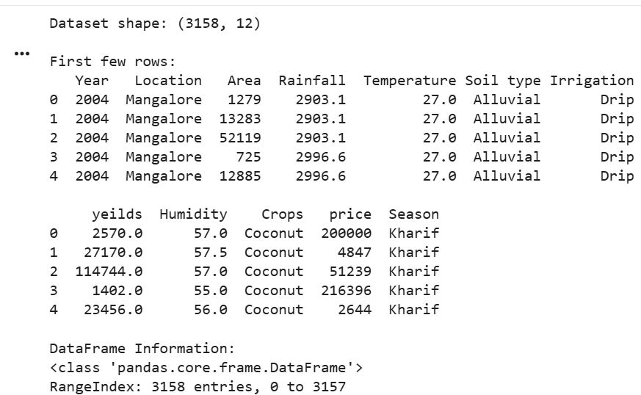
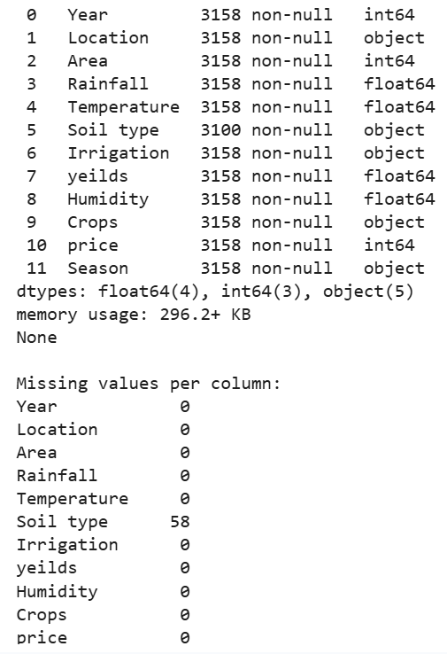
The results of preprocessing will be documented using the original and cleaned dataset dimensions, missing-value counts, duplicate counts, and any changes made to the data.
4. Exploratory Data Analysis (EDA)
Summarize the exploratory analysis performed — summary statistics, distributions, correlations, group-wise comparisons, and any patterns identified.
Exploratory Data Analysis is used to understand the structure, distribution, and relationships present in the agricultural dataset. The analysis will be conducted using Pandas, NumPy, Matplotlib, and Seaborn.
First, descriptive statistics will be calculated for numerical attributes such as rainfall, temperature, humidity, area, yield, and price, wherever these columns are available. These statistics will help summarize the central values and variation within the data.
Next, the distributions of numerical attributes will be examined using histograms and box plots. Categorical attributes, including crop type, season, soil type, irrigation, and location, will be analyzed using frequency counts and group-wise comparisons.
Correlation analysis will be performed on suitable numerical attributes to examine the strength and direction of relationships between variables. Comparisons across crops, seasons, and locations will also be considered to understand variations in agricultural production.
The EDA findings will be used to identify patterns associated with rainfall, soil conditions, irrigation practices, and crop production. All observations will be based on the actual results obtained from the dataset.
Code:
print("--- Descriptive Statistics for Numerical Variables ---")
display(df.describe())
print("\n--- Descriptive Statistics for Categorical Variables ---")
display(df.describe(include=['object']))
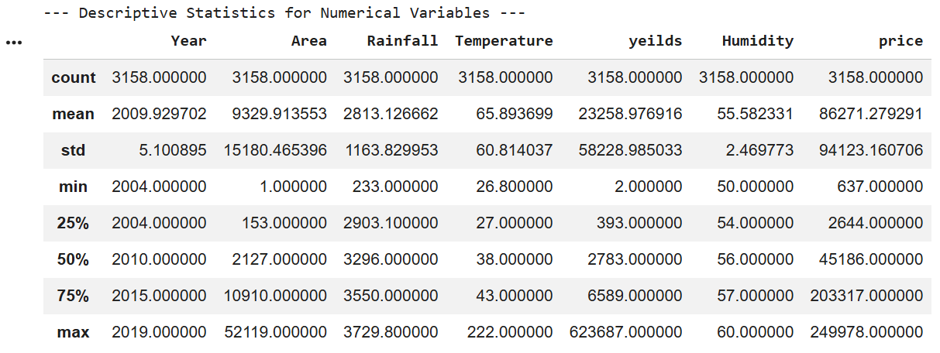
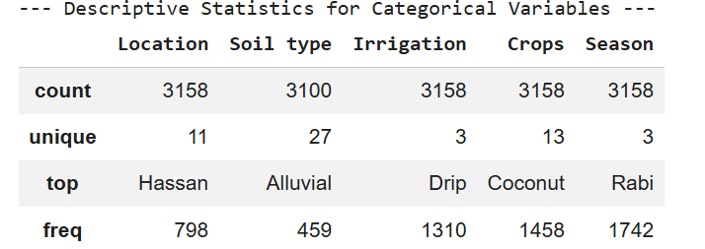
5. Data Visualization & Observations
Insert key charts/plots (bar charts, histograms, scatter plots, heatmaps, etc.) generated using Matplotlib/Seaborn/Plotly, along with a short observation for each visualization.

project, provided the relevant columns exist in your dataset.
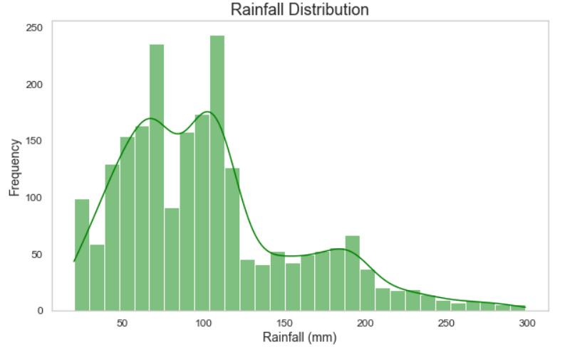
Figure 1: Distribution of Rainfall
Purpose: To examine how rainfall values are distributed across the records.
Observation to write: Describe whether rainfall values are concentrated in a particular range, widely spread, or affected by unusual values, based on your histogram.
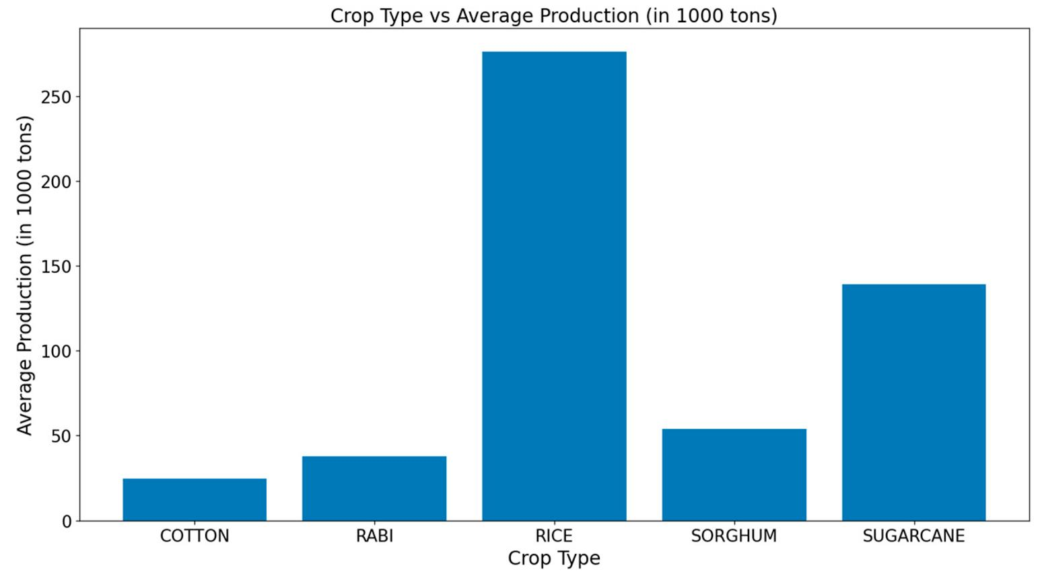
Figure 2: Crop-wise Production Comparison
Purpose: To compare crop production or yield among different crop types.
Observation to write: Identify the crops with the highest and lowest measured production or yield in your actual chart. State which measurement is being compared.
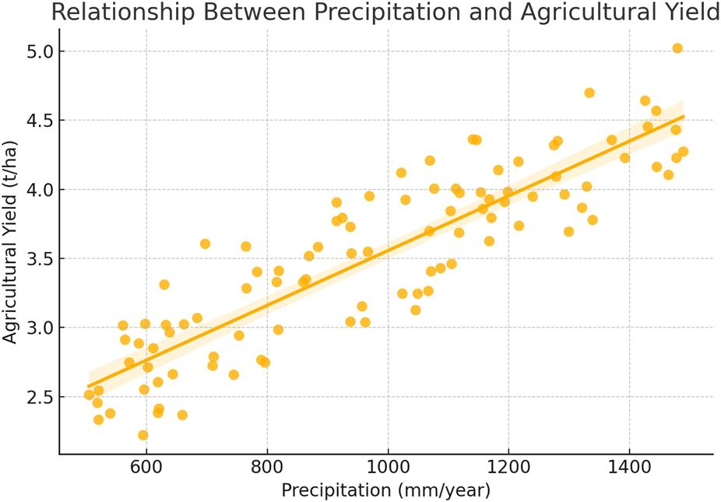
Figure 3: Rainfall vs Crop Yield
Purpose: To explore whether rainfall and crop yield have an observable relationship.
Observation to write: Describe whether the points suggest a positive, negative, weak, or unclear relationship. Do not assume that rainfall alone determines yield.
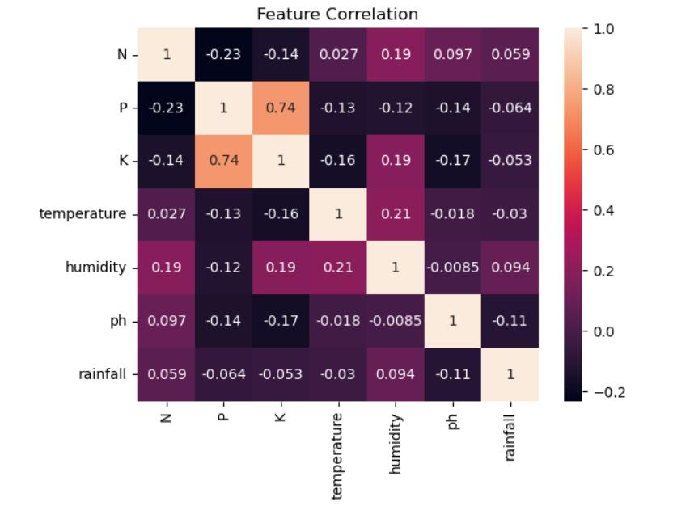
Figure 4: Correlation Heatmap
Purpose: To visualize correlations among suitable numerical variables.
Observation to write: Report the strongest relevant positive and negative correlations shown in your heatmap, including the variable names and coefficients.
Figure 5: Soil Type and Crop Yield Comparison
Purpose: To compare the distribution of crop yield across soil types, if both attributes are present.
Observation to write: Compare the medians, spread, and unusual observations across soil categories

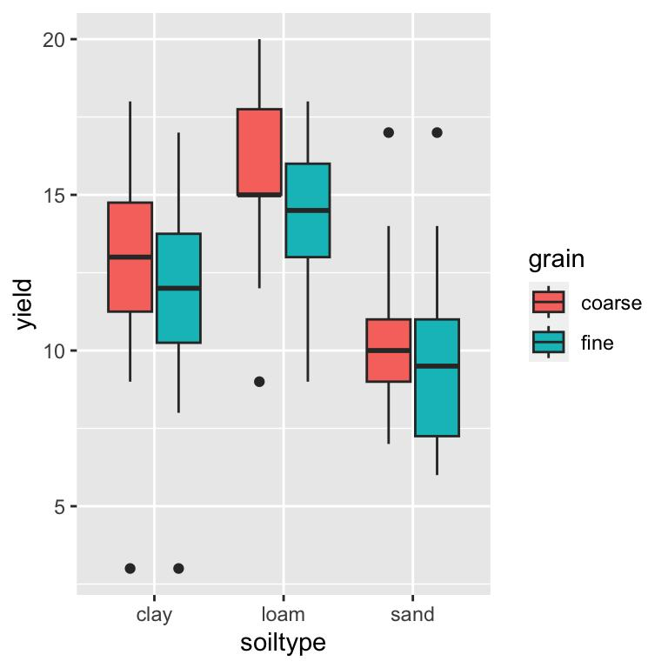
6. Statistical Analysis (Basic)
Present basic statistical interpretation — measures of central tendency and spread, correlation coefficients, hypothesis tests, or other relevant statistical techniques used to support the analysis.
Statistical analysis will be used to summarize agricultural data and examine relationships between relevant variables. Measures of central tendency, including mean and median, will be calculated for numerical attributes such as rainfall, temperature, humidity, and crop yield, where available.
Measures of dispersion, including minimum, maximum, range, standard deviation, and quartiles, will be used to understand the variability of the observations. These measures can help identify differences in environmental conditions and agricultural production across the dataset.
Correlation coefficients will be calculated for suitable numerical variables to assess the strength and direction of their linear relationships. A correlation coefficient close to +1 indicates a strong positive linear association, a value close to -1 indicates a strong negative linear association, and a value near 0 indicates a weak linear association.
Group-wise statistical summaries will also be used to compare agricultural production across crops, seasons, soil types, or locations, depending on the available attributes. The results will be interpreted in the context of the project objectives. Correlation will not be treated as proof of causation, and any statistical claims will be supported by the calculated results.
Code:
numerical_features = ['Area', 'Rainfall', 'Temperature', 'yeilds', 'Humidity', 'price']
stats_df = df[numerical_features].agg(['mean', 'median', 'std', 'min', 'max'])
print("--- Summary Statistics for Key Numerical Columns ---")
display(stats_df)
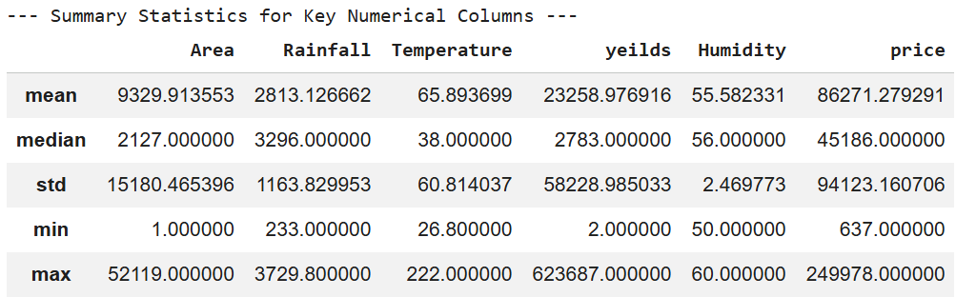
percentiles_df = df[numerical_features].describe(percentiles=[0.25, 0.5, 0.75])
print("\n--- Detailed Percentile Distribution ---")
display(percentiles_df)
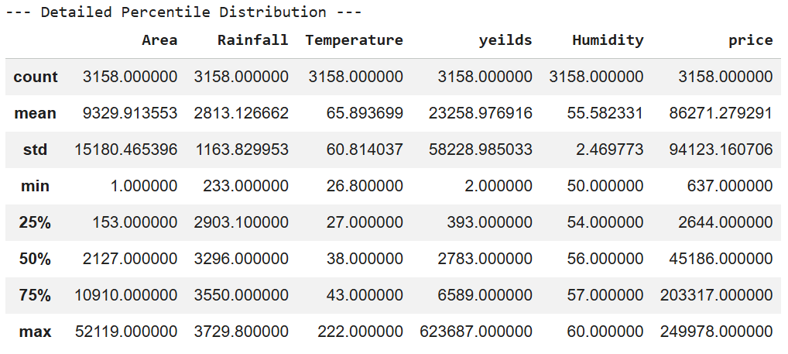
7. Key Insights & Interpretation
List the key insights derived from the analysis and interpret what they mean in the context of the chosen problem statement.
- Rainfall patterns: The rainfall distribution shows [describe the observed pattern]. This helps explain the range of rainfall conditions represented in the dataset.
- Relationship between rainfall and crop yield: The analysis indicates a relationship between rainfall and crop yield, with a correlation coefficient. This describes the association observed in the available data.
- Crop-wise variation: The comparison of crop types shows that. This indicates differences in agricultural production or yield across the crops represented.
- Soil and irrigation conditions: The analysis of available soil and irrigation attributes shows This provides information about how these conditions vary across the dataset.
- Other relevant factors: The analysis identifies This helps broaden the understanding of factors associated with crop production.

8. Conclusion & Future Scope
Summarize the overall findings of the project and suggest possible extensions or improvements for future work.
Conclusion
The project, “Impact of Rainfall and Soil Parameters on Crop Production,” focuses on analyzing agricultural data to understand the relationship between environmental conditions and crop production. The project uses Python-based data analytics techniques, including data cleaning, preprocessing, descriptive statistics, Exploratory Data Analysis (EDA), correlation analysis, and visualization.
The analysis examines relevant attributes such as rainfall, temperature, humidity, soil type, irrigation, crop type, season, and crop yield, depending on their availability in the dataset. Statistical summaries and graphical representations are used to identify patterns, compare agricultural conditions, and understand variations in crop production.
The project aims to convert agricultural data into meaningful information that can improve understanding of crop production and water management. The final conclusions will be based on the actual findings obtained from the dataset. The results may support better agricultural analysis and provide a foundation for informed irrigation and crop-management decisions.
Future Scope
- Smart irrigation system: The analysis can be extended into a system that recommends irrigation based on rainfall, soil moisture, crop requirements, and other relevant factors.
- Real-time monitoring: Sensors and weather data could be incorporated to monitor soil moisture and rainfall conditions continuously.
- Crop yield prediction: Machine learning algorithms could be explored to predict crop yield using relevant environmental and agricultural attributes.
- Rainwater management: Future work could examine methods for collecting and storing excess rainwater for use during periods of low rainfall.
- Interactive dashboard: An agricultural dashboard could present rainfall patterns, crop comparisons, and other findings in an accessible format for farmers and agricultural planners
9. References
List all references, datasets, articles, and tools cited in the project (use a consistent citation style).
- Kaggle. Agricultural Dataset – Karnataka. https://www.kaggle.com/datasets/imtkaggleteam/agriculture-dataset-karnataka
- Government of India. Open Government Data Platform India. https://www.data.gov.in/
- Food and Agriculture Organization of the United Nations (FAO). https://www.fao.org/
- Python Software Foundation. Python Documentation. https://docs.python.org/3/
- pandas Development Team. pandas Documentation. https://pandas.pydata.org/docs/
- Matplotlib Development Team. Matplotlib Documentation. https://matplotlib.org/stable/

10. AI Tool Usage Declaration
As per Section 4 & 15 of the PBL guidelines, any use of AI tools (e.g., ChatGPT, GitHub Copilot, Google Colab AI, Gemini, Claude) must be transparently declared below.
☐ No AI tools were used in this project.
☐ AI tools were used, as detailed below:
AI Tool Used | Purpose (e.g., debugging, documentation) | Extent of Use / Section Applied
chatgpt | In python code to detect the errors | Python code

11. Project Links & Deliverables
GitHub Repository Link: _______________________________________________________
Python Notebook (.ipynb) File Name: Imapct_of_rainfall.ipynb
PBL Report File Name: Impact_of_Rainfall_and_Soil_Parameters_on_Crop_Production.docx
Confirm that the GitHub repository includes the code, notebook, and a PBL report as required.
☐ GitHub repository includes code, notebook, and a PBL report and README

12. Report Structure Checklist (Section 8 Compliance)
S. No. | Report Section (as per Section 8 format) | Included (✓)
1 | Title Page
2 | Introduction & Problem Statement
3 | Dataset Description & Source
4 | Data Cleaning & Preprocessing
5 | Exploratory Data Analysis (EDA)
6 | Data Visualization & Observations
7 | Statistical Analysis (Basic)
8 | Key Insights & Interpretation
9 | Conclusion & Future Scope
10 | References
13. Declaration by Student(s)
I/We hereby declare that this Mini Project Report is our own original work, prepared using publicly available/open datasets. All sources of data, references, and AI tool assistance have been duly acknowledged. I/We understand that any instance of plagiarism in code or report will attract strict academic action, as per Section 15 of the PBL guidelines.
Team Leader Signature: _____________________________________________
Team Member Signature(s): _____________________________________________
Date: ____________________________________________________________

14. For Faculty Use Only — PBL Final Report Evaluation
Evaluation Component B — PBL Final Report Submission | Mid-Term (PBL Based): 10 Marks (Section 10 of PBL Guidelines)
Evaluation Criteria | Max Marks | Marks Awarded
Data Cleaning & Preprocessing | 2
Exploratory Data Analysis (EDA) | 2
Visualization & Observations | 2
Statistical Analysis | 2
Insights, Interpretation & Conclusion | 2
Total (out of 10) | 10
Faculty Remarks:

Faculty Mentor Signature: _____________________________________________
Date: ____________________________________________________________

